**Android based Fitness Application**

**For Blinds**

**Submitted in partial fulfillment of the requirement for the award of**

**the degree**

**of**

**Bachelor of Technology**

**in Computer Science Engineering and Information Technology**

***by***

**Anjali Bajaj(15CSU026)**

**Anjali Rana(15CSU027)**

**Ashuti Mathur(15CSU047)**

**Under the supervision of**

**Ms. Hitesh Yadav**



**Department of CSE & IT**

**The North Cap University**

**Gurugram**

**CERTIFICATE**

This is to certify that the Project Report entitled, **Android applications for blinds** submitted by **Anjali Bajaj (15CSU026), Anjali Rana (15CSU027) and Ashuti Mathur (15CSU047)** to **The NorthCap University, Gurugram, India** is a record of bonafide Project work carried out by them under my supervision and guidance and is worthy of consideration for the award of the degree of his B**achelor of Technology** in **Computer Science Engineering and Information Technology** of the institute.

**Date: .............……… Ms. Hitesh Yadav**

**ACKNOWLEDGEMENT**

We would like to express our sincere gratitude to our supervisor, Ms.Hitesh Yadav, whose contribution in stimulating ideas, encouragement and active guidance has helped us to decide the idea for the project and make this report. We would like to extend our deepest appreciation to all those who provided us their support and helped us in this endeavor.

We our also indebted to our teachers and friends who have provided us with the knowledge and encouragement to help us bring in our best to this project.

Anjali Bajaj(15csu026)

Anjali Rana(15csu027)

Ashuti Mathur(15csu047)

**TABLE OF CONTENTS**

**1) Introduction …………………………………………………..8**

1.1) Artificial Intelligence………………………………..…... 8

1.2) Android……………………………………………...…... 8

1.3) Objective……………………………………………….....9

**2)** **Modules…………………………………………………..…...10**

2.1)Chat bot……………………………………………….….10

2.2)Music Player………………………………………… .….11

2.3)Pedometer……………………………………………..….11

2.4)Food Calorimeter……………………………………. …..11

2.5)Heart rate sensor………………………………………….11

**3)Comparison…………………………………………………..12**

**4) Context Analysis Diagram………………………………….13**

**5) Data Flow Diagram Level 1…………………………………14**

**6) Use Case Diagram………………………………………...…15**

**7) ER Diagram……………………………………………….…16**

**8) Platforms……………………………………………………..17**

**9) Challenges and Issues……………………………………….20**

9.1)Challenges……………………………………………….20

9.2)Issues…………………………………………………….20

**10)Interface Design……………………………………………..21**

**11) Implementation……………………………………………..23**

11.1)Software Development method…………………………23

11.2)Development of different modules……………………...23

11.2.1)Development of Chabot………………………...23

11.2.2)Development of music player…………………..23

11.2.3)Development of calorimeter……………………24

11.2.4)Development of pedometer…………………….25

**12)Outcomes…………………………………………………….27**

**13)Implementation of modules………………………………...27**

**14) Workflow…………………………………………………...37**

**15) Future Enhancements……………………………………..38**

**16) Feasibility…………………………………………………..38**

**17) Bibliography……………………………………………….39**

**LIST OF FIGURES:**

Fig 1. Context Analysis Diagram for the app…………………………. 14

Fig 2. Data Flow Diagram…………………………………………….. 15

Fig 3. Use Case Diagram………………………………………………. 16

Fig 4. ER Diagram……………………………………………………... 17

Fig 5. Work Flow of the app………………………………………….... 19

Fig 6. Graphical representation of main page………………………….. 22

Fig 7. Graphical representation of pedometer ………………………… 22

Fig 8 Graphical Representation of Calorimeter………………………... 23

Fig 9 Graphical Representation of media player………………………. 23

Fig 10 Prototype for media player in app……………………………… 25

Fig 11 Prototype for calorimeter………………………………………. 26

Fig 12 Work flow of the app…………………………………………... 27

Fig 13 Login Page of the app………………………………………….. 29

Fig 14 Registration Page of the app…………………………………… 30

Fig 15 Main Page……………………………………………………… 31

Fig 16 Media Player ………………………………………………….. 32

Fig 17 Registration page for BMI/Calorimeter……………………….. 33

Fig 18 Calorimeter Results Page…………………………………….... 34

Fig 19 Pedometer Results Page……………………………………….. 35

Fig 20 Heart rate sensor/input page…………………………………… 36

Fig 21 Heart Rate Results Page……………………………………….. 37

Fig 22 Gantt Chart for the project…………………………………….. 38

**ABSTARCT**

Our objective is to help the blinds for maintaining their physical and mental health through voice-based assistance. We believe that with our proposed platform we can help blind people as well as those users who cannot read and write. Despite rapid technological advances, little progress has been made towards improving the well-being of blind people.

We are providing an online platform that will help them to gain the benefits of technology and keep themselves fit both mentally and physically. Users will not have to depend on others for the working of their application as it is provided with a voice assistant. Users will be able to operate their application through voice commands and also receive results verbally. Overall this project should provide a benefit to visually impaired people who are not able to make the fullest use of the technology.

**LIST OF TERMINOLOGIES**

**.apk file:** Android application package file. Each Android application is compiled and packaged in a single file that includes all of the application's code (.dex files), resources, assets, and manifest file.

● **Activity:** A single screen in an application, with supporting Java code, derived from the Activity class. Most commonly, an activity is visibly represented by a full screen window that can receive and handle UI events and perform complex tasks, because of the Window it uses to render its window.

● **Drawable:** A compiled visual resource that can be used as a background, title, or other part of the screen. A drawable is typically loaded into another UI element, for example as a background image.

● **Intent:** An message object that you can use to launch or communicate with other applications/activities asynchronously.

● **Layout Resource:** An XML file that describes the layout of an Activityscreen.

● **View:** An object that draws to a rectangular area on the screen and handles click, keystroke, and other interaction events. A view is a base class for most layout components of an Activity or Dialog screen. It receives calls from its parent object to draw itself, and informs its parent object about where and how big wants to be.

**1. INTRODUCTION**

In today`s changing lifestyle, we all need to keep a constant check on our physical health. But what about those who are blind? Hence, this all-in-one android based mobile health application. Thus, what is better than having a mobile application for keeping a constant check on our health. This application will assist the blinds in keeping a track on their health and help them lead a better and healthy life.

For making the app, we will be using different technologies that are prevalent in today`s world.

**1.1. Artificial Intelligence**

Artificial intelligence or AI is expanding its horizons. From creating chat bots to creating fully functional humanoids, AI is definitely something that is hard to miss. For the project, we will be using a voice based chat bot that can interact with the user or operate by speech. We will be integrating the bot in the application so as to make the operation easier for the user. Instead of searching for the application in the mobile, one can now speak the name of the application and the application will be launched. This is a major factor in assisting the blinds as now they won`t have to depend on someone to help them to launch the application in their mobiles.

**1.2.Android**

We will be deploying the application on android platform. We will also be programming in android studio so as to create the application. Along with using android studio for programming for the application, we will also be using a number of API`s provided by Google for tracking health. The application will have a pedometer that will count the number of steps that user has taken in a predefined time limit and will also tell the distance covered by the user.

There will be a calorie counter that will help the user to track the calorie intake and how much calories he or she should take in order to stay fit. Along with these features, there will also be a media player that will provide entertainment during workout to the user.

An additional feature will be a clock that will help the user to balance/track his or her sleep cycle. This feature is useful because sleep plays an important role in maintaining one`s health.

**1.3. Objective**

The project aims at developing an android based mobile application for the blinds. This app will help them to take care of their fitness by keeping a track of several different aspects.

The main objective of this application is to assist the blinds and in taking good care of their health and imbibe healthy practices in their lifestyle. The app also focuses on integrating different components like a pedometer, calorie counter and other modules that are of utmost benefit in keeping a track of one`s well-being and health. Android platform is easily accessible to almost everybody. Hence we chose the platform so that we can reach up to a wider part of society.

**2. MODULES**

Our application mainly consists of 5 features:

**2.1 Chat Bot** - A [computer program](https://en.wikipedia.org/wiki/Computer_program) which conducts a [conversation](https://en.wikipedia.org/wiki/Conversation) via auditory or textual methods. Such programs are often designed to convincingly simulate how a human would behave as a conversational partner.

**2.2 Music Player**- to keep their minds fresh and the songs will be played through an interaction with the chat bot.

**2.3 Pedometer** - It will also calculate the number of steps taken by them per day week and its main objective is to keep them physically fit.

**2.4 Food calorimeter**- Chat bot tells what all food items to be taken in order to stay fit from a given number of food items with their calories and quantity of food items to be taken.

2.5 **Heart Rate Calculator**- Chat bot also tells the heart rate for a person

**2.1 Chat Bot**

In our application we will include chat bot which makes it easy to integrate speech recognition with natural language processing in android devices. It responds by listening to voice commands of the user.

Once the application is installed, chat bot will first introduce itself to the user just like siri in the apple iphone. Then the chat bot will give commands to the user to register itself with the application. Whenever the application is opened by the user, he/she will have to choose from the options provided .Once the user chooses his/her desired option, the chat bot opens it for the user.

**2.2 Music Player**

In our application we will add music player and it will also interact with the chat bot so that visually impaired can follow the commands and fulfill their wish of listening music instead of taking help from others. It also helps the user to download music so that the person can listen to his/her favorite song.

**2.3 Pedometer**

Our application includes pedometer that interacts with the user using voice assistance provided by the application. Pedometer helps in keeping track of the steps you take while doing aerobics, running, walking, steps exercise. These applications work with the phones which have the Accelerometer sensor built in it. While running, this application will monitor the change in accelerometer and based on it will conclude if the step is taken. When the user choose the option for the pedometer in the application, then the pedometer will start calculating its steps and it will also update the user about the steps taken by him at a regular interval of time.

**2.4 Calorie Counter**

In our application we will include Calorie counter that interacts with the user using

voice assistance provided by the application. The main function of calorie counter is to calculate the amount of food a person should take to keep himself healthy and fit. It tells the calorie count in a food item and also the quantity of food item that the user should consume.

**2.5 Heart rate Calculator**

In our application we will include Heart rate calculator that interacts with the user using voice assistance provided by the application. The main function of heart rate calculator is to calculate the heart beat of the person and also tells the normal heartbeat of the person.

**3. COMPARISON**

Existing model:

1. Features like pedometer, food calorimeter, music player are already existing features in smartphones. But we usually find them separately.
2. We need multiple apps to use these features.
3. There is no assistance provided for visually impaired.

Proposed model:

1. Apps like music player, pedometer and food calorimeter are integrated in one application to make it convenient for the users.
2. It helps them to stay mentally and physically fit.
3. Has a built in chat bot which interacts with the users.
4. Opens all the apps on voice recognition.
5. **CONTEXT ANALYSIS DIAGRAM**

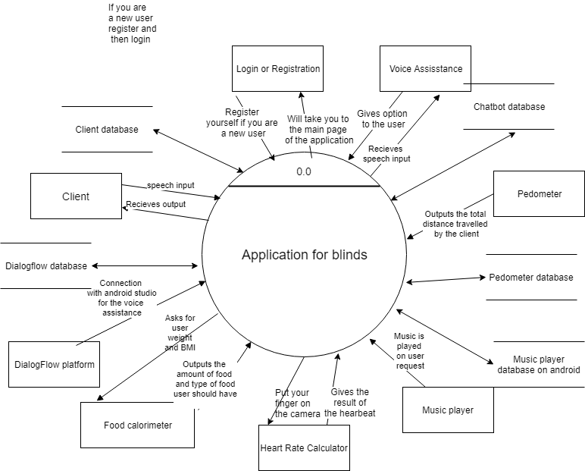

Fig 1 Context Analysis Diagram

1. **DATA FLOW DIAGRAM LEVEL 1**

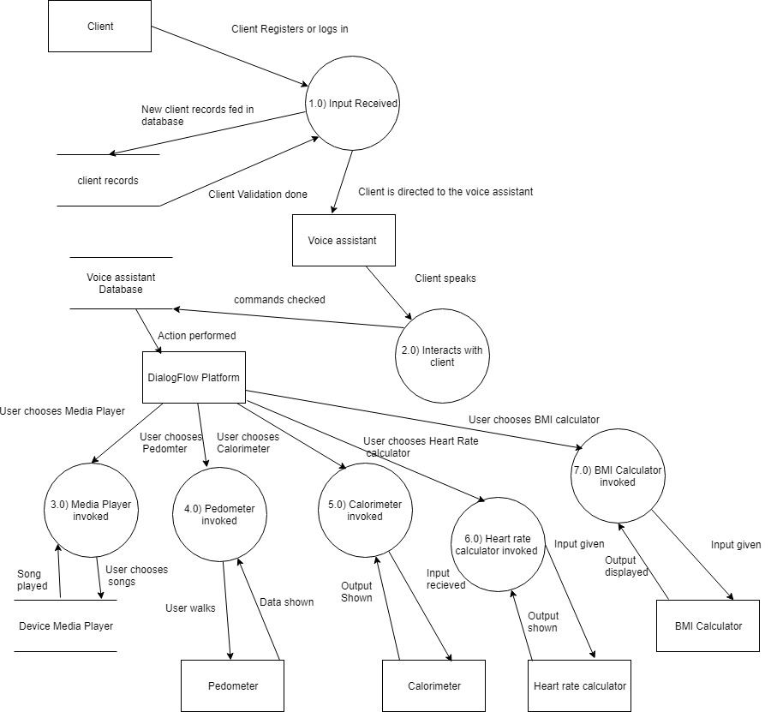

Fig 2 Data Flow Diagram for the application

1. **USE CASE DIAGRAM**

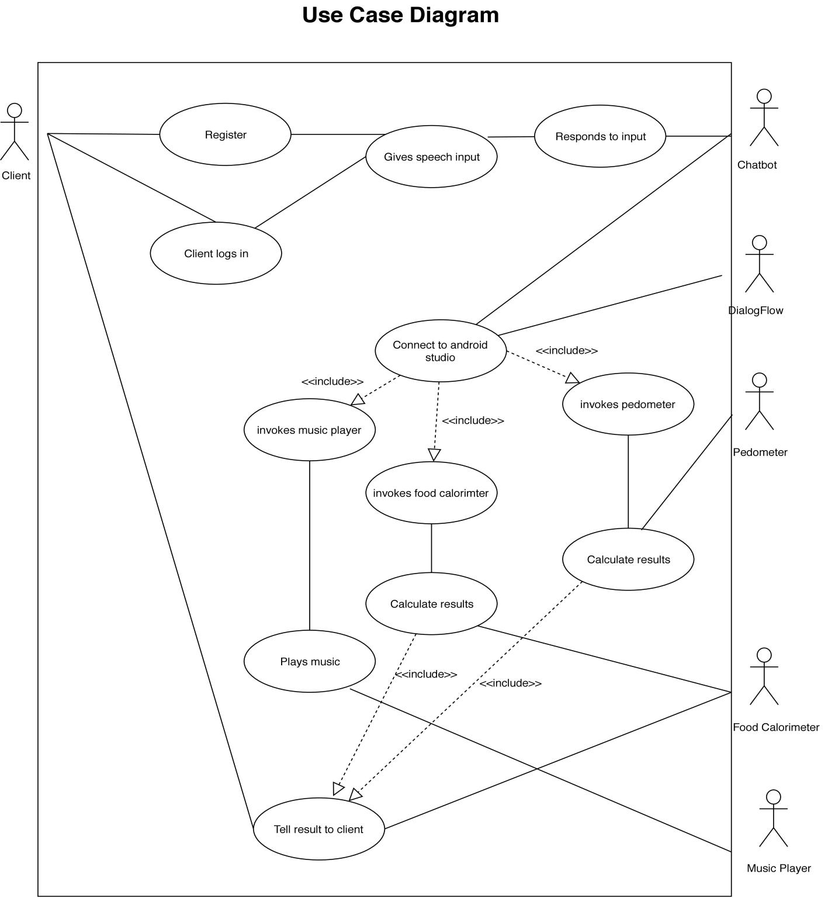

Fig 3 Use Case Diagram for the app

1. **ER DIAGRAM** 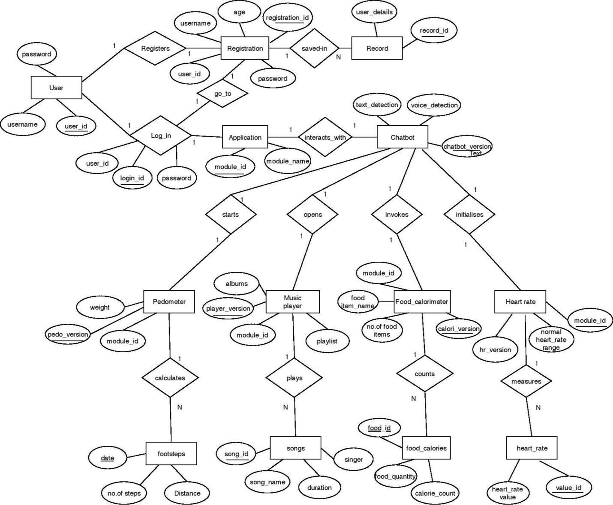

Fig 4 ER Diagram for the app

1. **PLATFORMS**

Throughout the duration of the project, we will be using the following platforms:-

**Android Studio:-**

We will be using android studio to build the app. And so, app will be an android based application. We chose the android platform, because of the following reasons:-

* Android is the most popular OS nowadays.
* Android powers more than billion smartphones and tablets.
* Android is open source :-The Android platform is open source which means the Android Software Development Kit (SDK) can be leveraged without having to worry about the licensing costs or royalty. Developers can interact with the Android developer community for the forthcoming versions which they can incorporate into their Android app development projects. These benefits make Android a lucrative prospect for enterprises, device manufacturers and wireless operators alike, resulting in rapid development of the applications.
* **Low Investment Costs:** Android has a relatively low barrier to entry. Its Software Development Kit (SDK) is available for free to developers which significantly reduces the development costs.
* The API.AI Android SDK makes it easy to integrate speech recognition with [API.AI](http://www.api.ai/) natural language processing API on Android devices. API.AI allows using voice commands and integration with dialog scenarios defined for a particular agent in API.AI.

**Mobile Application:-**

The app is a mobile application. This means, it is deployable on mobile environment. It will be a lightweight application. Application will be for android operating system. The app will be compatible with any device which has android operating system.

**Api.ai:-**

It is also known as DialogFlow. We will be using this api to create the chatbot. The chatbot will be a voice assistant. The user will be giving commands in the form of speech, chatbot will perform the action. Entire application will be controlled by the intelligent bot.

Api.ai is used to create this voice assistant. We will be training the bot using api.ai. We will be using agents, entities and intents to train the bot and make it respond to user`s inputs/commands.

Later on, after the bot is trained and is ready to be deployed, we will connect the bot to our android application and connect all the modules with the bot.

Agents are best described as NLU (Natural Language Understanding) modules. These can be included in your app, product, or service and transform natural user requests into actionable data.

An **intent** represents a mapping between what a user says and what action should be taken by your software.

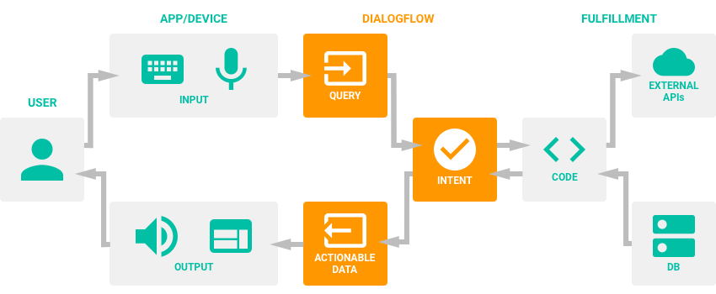

Fig 5 Work Flow of the app

**Firebase**

Firebase is a mobile and web app development platform that provides developers with a plethora of tools and services to help them develop high-quality apps, grow their user base, and earn more profit.

The Firebase Realtime Database is a cloud-hosted NoSQL database that lets you store and sync between your users in realtime. The Realtime Database is really just one big JSON object that the developers can manage in realtime.

**Hardware:**

● A phone with a touch screen interface.

● Phone Ram should be of a minimum 1 GB.

● Internet connectivity.

● The phone should have USB debugging mode for development and testing purposes.

**Software :**

● Operating system should be android 4.1 or higher.

● Support of other basic and 3rd party applications like maps, calender, camera, web connection etc.

● Android studio for development and testing of the application.

● Android debug bridge (ADB) driver to test the app.

**9. CHALLENGES AND ISSUES**

* 1. **Challenges**

The following issues were identified during the designing phase of the project:

* The app needs to be fully operational using voice commands. This would mean that all the modules are operational through voice commands. Thus, the standard API needs to be changed accordingly.
* The media player needs to be connected to an external database which might contain upto hundreds of media files. So connection to the database should be properly made and it should be functional.
* The Calorimeter and Pedometer modules are created using Google API`s. They should be integrated properly in the app.
* Biggest challenge will be to integrate all the modules together and connect them to the chatbot.
  1. **Issues Identified**

The following issues were identified :-

* The Chatbot is operational using certain commands.
* The integration of modules is a major issue.
* Integrating the chatbot with various modules .
* Making the chatbot more intelligent.
  1. **INTERFACE DESIGN**

Calorimeter

Media Player

Pedometer

**2.2 Pedometer**

Fig 6 Graphical Representation of Main page of the app

Total Number of Steps:-

Fig 7 Graphical representation of Pedometer

Search

Remove

Add

Fig 8 Graphical Representation of Calorimeter

Song Name

Play/Stop

Play/Stop

Song Name

Fig 9 Graphical Representation of Media player

**11 . IMPLEMENTATION**

**11.1 Software Development Methodology**

The Agile Approach will be used for the implementation of the project. As the prototypes are created, they are evaluated and tested and feedback is taken for the same. The approach will be suitable for the project so as to make the app according to the requirements specified.

The approach was suggested due to the fact that in Agile Approach, the working software is delivered more frequently. Also, maximum user/customer benefit is ensured. The approach also welcomes any late changes in the requirements. This is a major factor in choosing the suitable software development methodology.

**11.2 Development of different modules**

For the development of different modules in the project, Android Studio will be used.

**11.2.1 Development of Chatbot**

For the development of Chatbot, an API will be used. This API will be integrated with the module and voice assistance will incorporated in the app.

The app will be operated through voice assistance only.

**11.2.2 Development of Music Player**

For the development of music player, external database will be used so as to store all the media content. This database will be connected to the app and will be functional through the app by voice assistance.

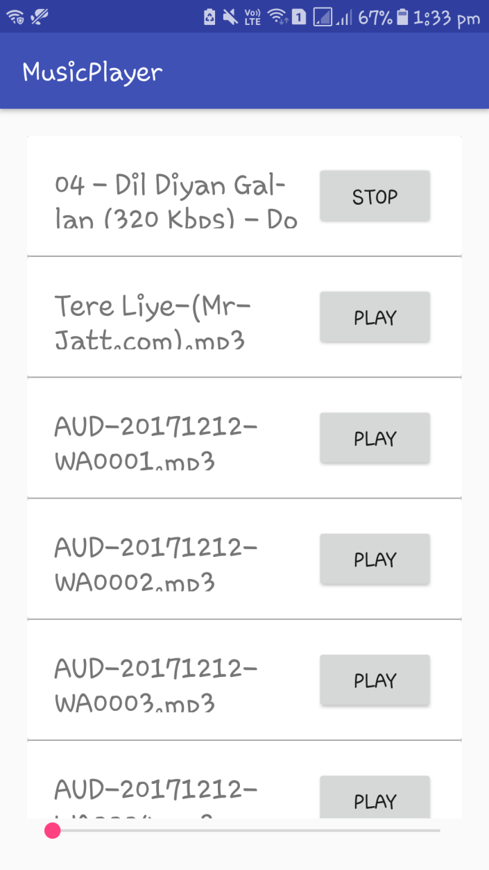

Fig 10 Prototype for Media Player in the app.

The above figure shows a prototype for the front end of the music player in the app.

**11.2.3 Development of Calorimeter**

For the development of the calorimeter, Google Fit API will be used. The API will be incorporated in the app. Every time the module is used, the API will be called.

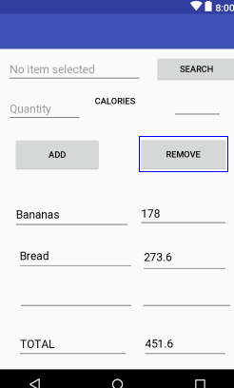

Fig 11. Prototype for Calorimeter

**11.2.4 Development of Pedometer**

For the development of pedometer, Google Fit API will be integrated in the code. The module will be integrated with the chatbot so as to enable the voice assistance.

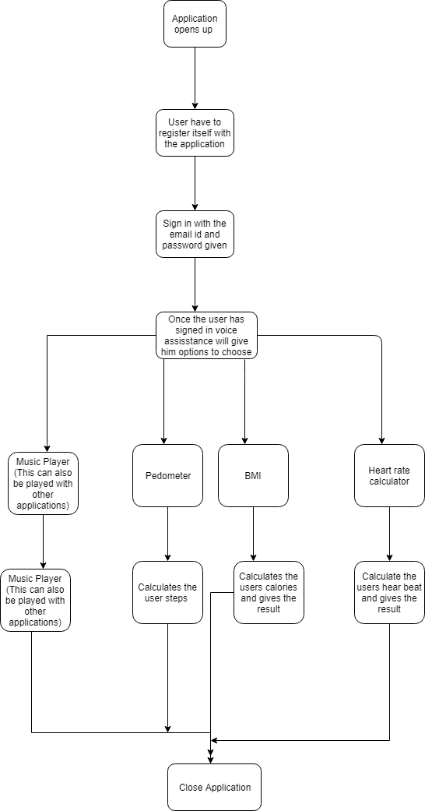

Fig 12 Work Flow of the app

* 1. **OUTCOMES**

Technology is increasing with time and people are making its use to the fullest by being updated with the latest technology. More and more applications are being made in order to make lives of the people living on this planet easy and stress-free. But is everybody able to enjoy the benefits?

People who can’t see properly or listen properly or with any other disability are not always able to use these opportunities.

So our application is a small step towards reducing that gap. It helps visually impaired people to stay mentally and physically fit. A voice assistance helps them to use an app which before could not be used by them. Through this app they will be able to keep a track of their mental health by listening to music through a voice assisted music player. They will be able to keep a track of

their steps and count the calories of the food they eat daily. This will help them to get a better understanding of their diet. This app can be used by everyone who wants a healthy life.

* 1. **IMPLEMENTATION OF MODULES**

**Voice assistant:**

The voice assistant that controls the entire app is made and is functional. It tells the users about all the modules and tells the user about the results.

**Heart rate sensor:**

This module senses the heart rate of the user. The results will be communicated to the user via voice assistant.

**BMI indicator:**

This module calculates the BMI of the user and communicates to the user.

**Food calorimeter:**

This module calculates the total calorie intake of the user.

**Pedometer:**

This module counts the number of steps taken by user.

**Media player:**

This module plays the songs in the background.

This figure shows the login page for a registered user. The user can input the credentials and can log into the app to use the modules.

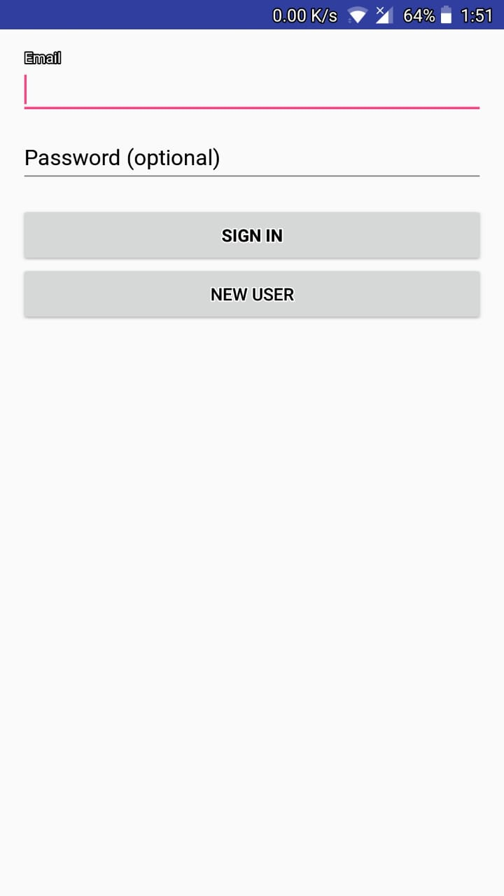

Fig 13 Login Page of the app

The figure shows the Registration page for a new user. The user needs to provide the details and they will be fed into the database

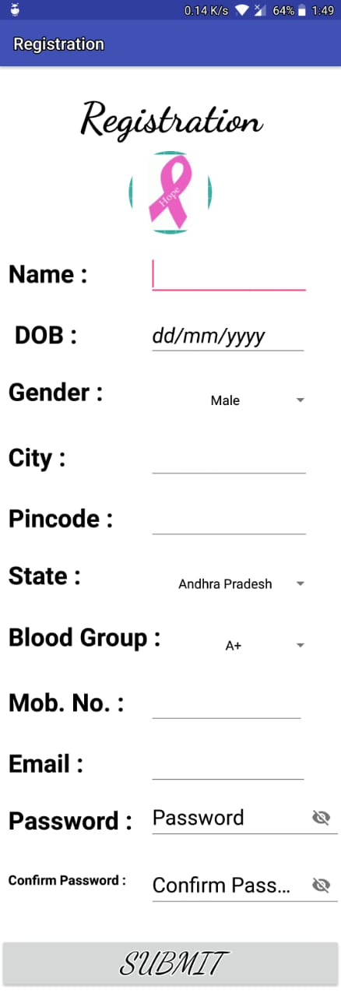

Fig 14 Registration Page of the app

The figure shows the main page of the application. It shows the modules of the app. The voice assistant communicates the module name to the user via speech.

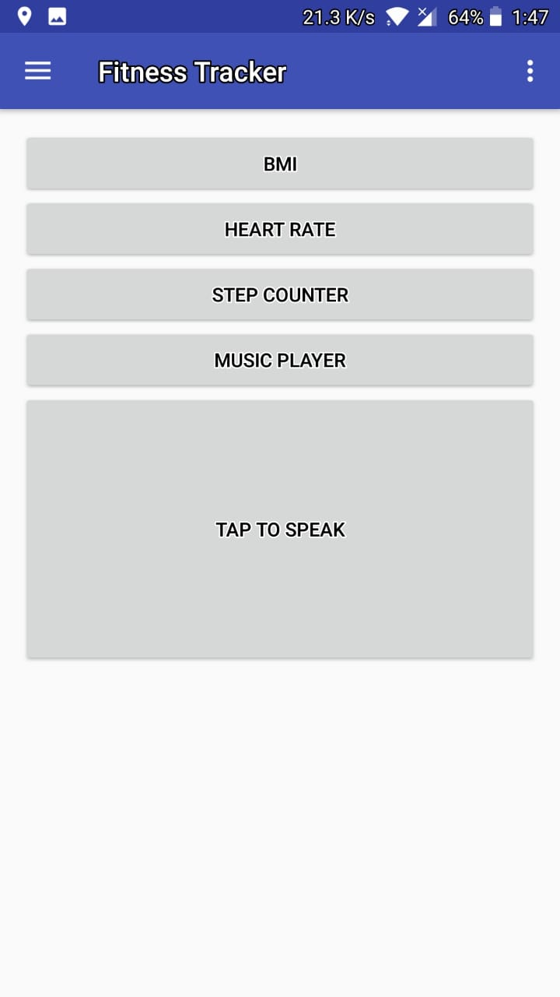

Fig 15 Main page of the app

This figure shows the Media Player. The song will be chosen by the user and the same will be played in the background.

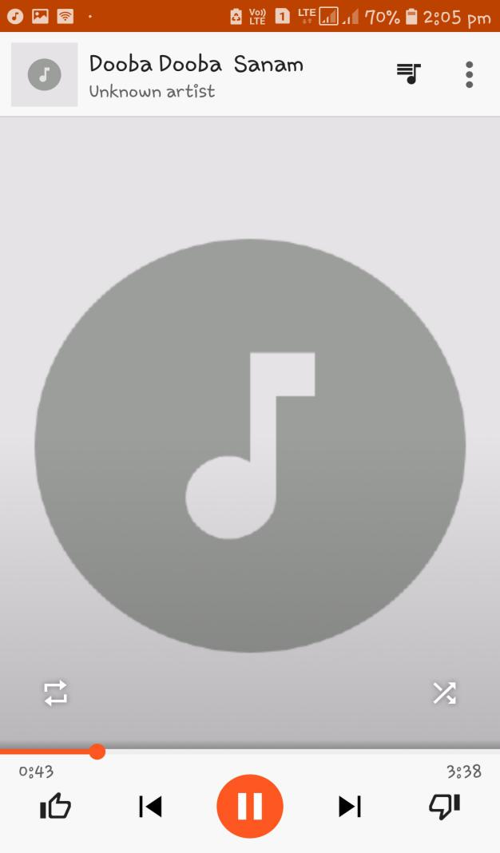

**Fig 16 Media Player**

The figure asks the user for the input to take the user details to calculate BMI and calories taken by the user

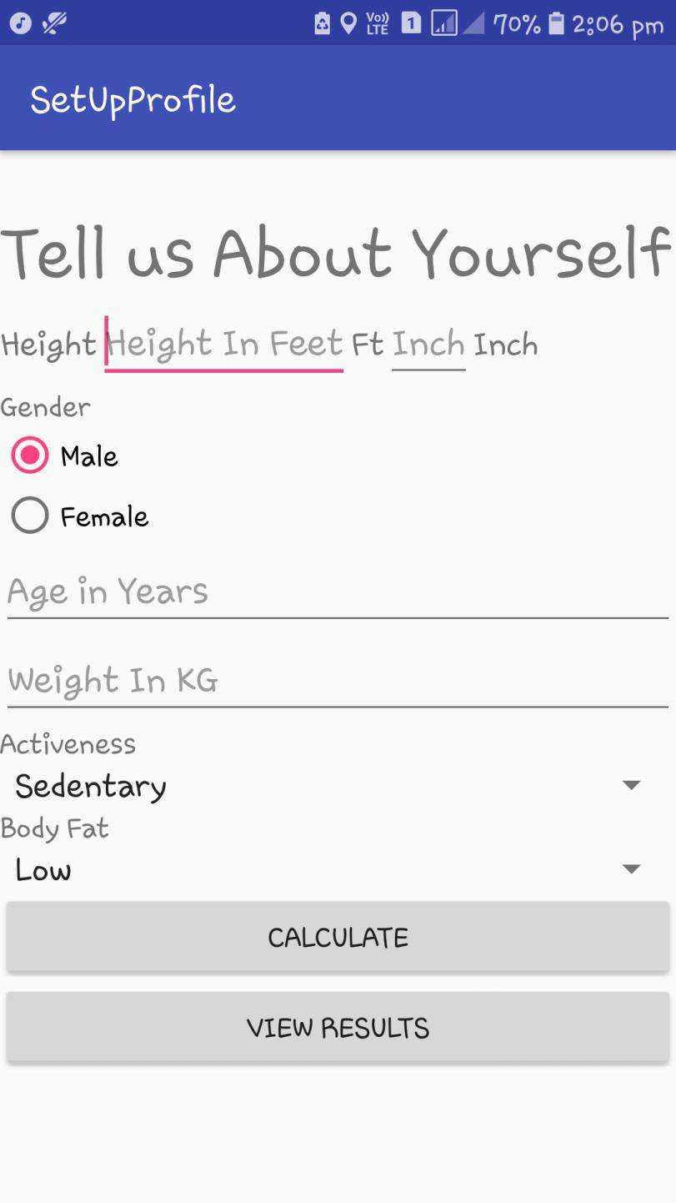

Fig 17 Registation Page for BMI/Calorimeter

The fiigue shows the result of the BMI calculations and the calories needed for the user.

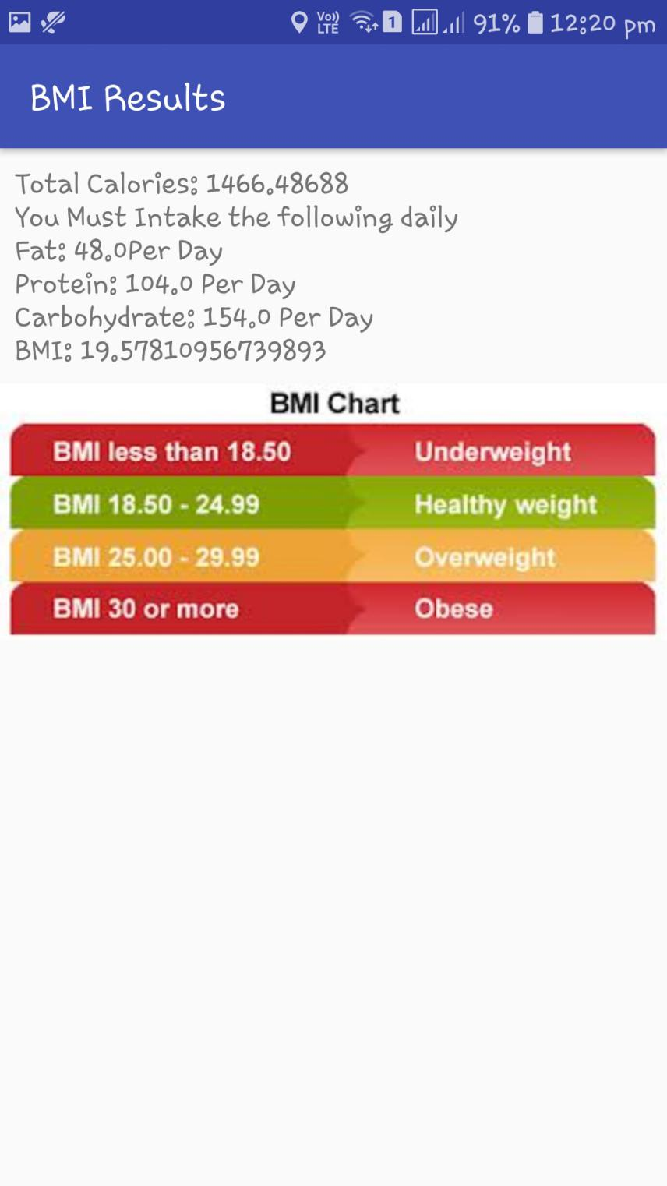

Fig 18 Calorimeter Results Page of the app

The figure shows the number of steps of user.

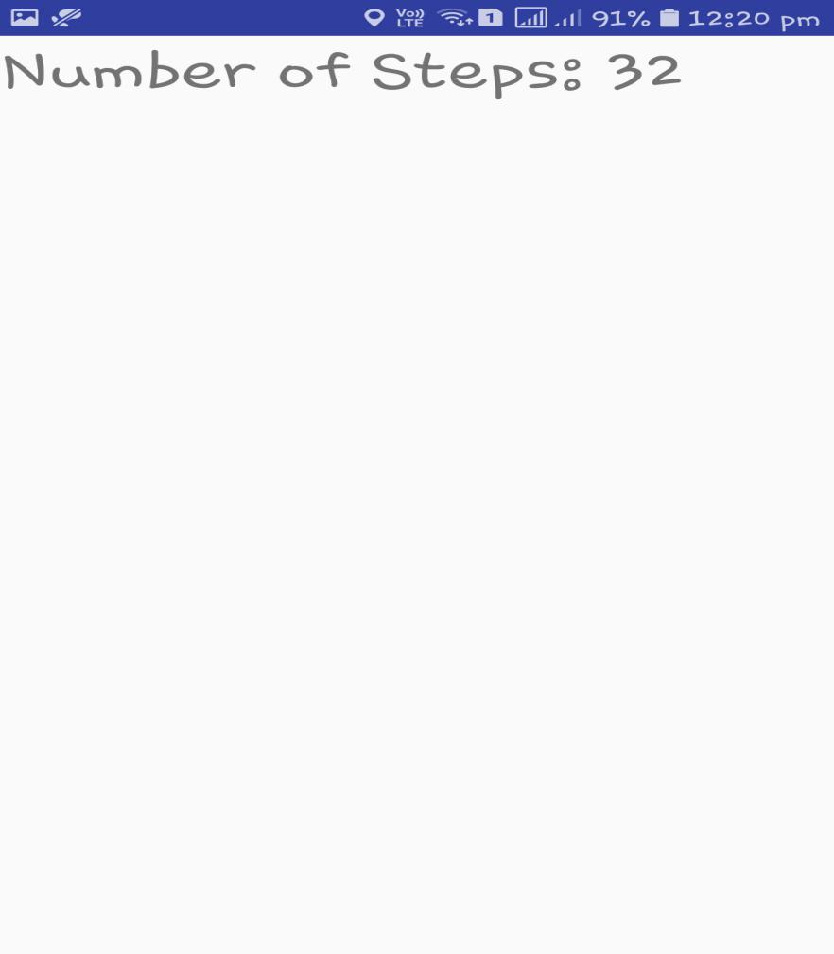

Fig 19 Pedometer Results

The figure shows the heart beat sensor in the app. It communicates the result to the

user via voice assistant

. 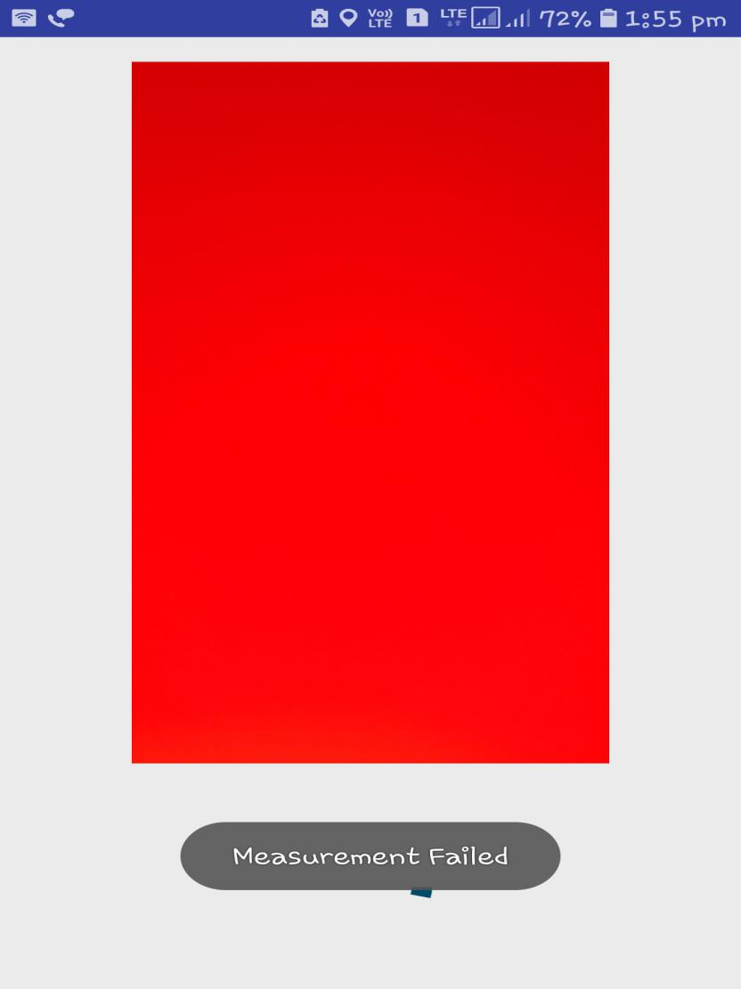

Fig 20 Heart rate sensor/input page

The figure shows the heart beat of the user and the same is communicated to the user via voice assistant.

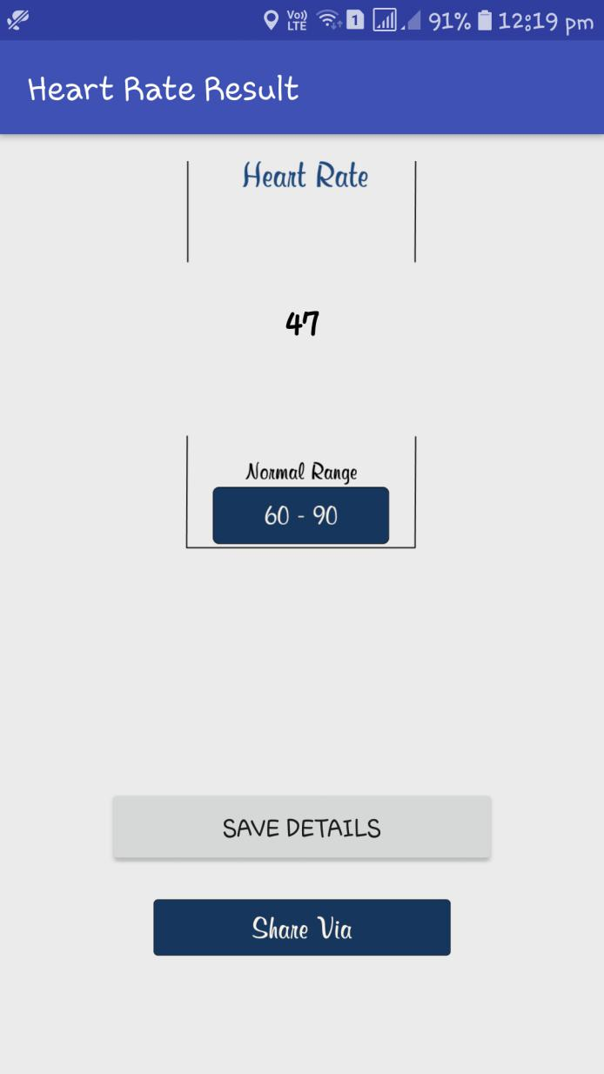

Fig 21 Heart rate result page

* 1. **WORKFLOW**

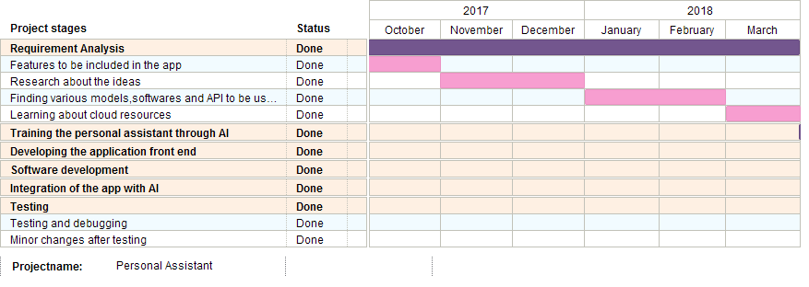

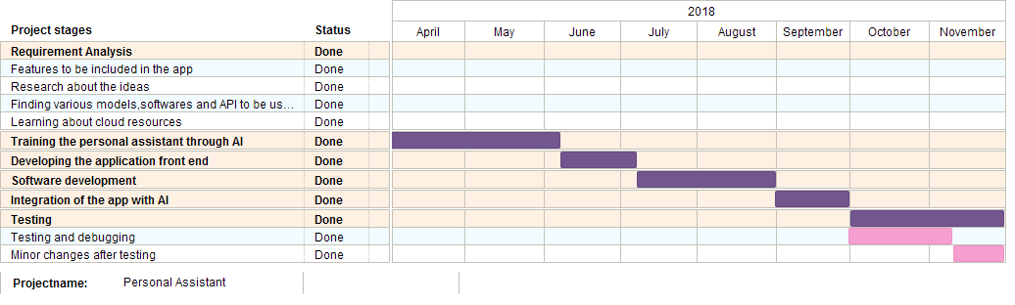

Fig 22 Gantt chart for the project

* 1. **FUTURE ENHANCEMENTS**

In future, we are looking to integrate more API’s and put our app in Google Play Store, so to bring out this project in a business perspective way and earn money with that and then look to bring some features which can also work out without Internet in order to increase the traffic and be in the market.

* 1. **FEASIBILITY**

Our project provides 70% efficiency that can help visually impaired to run this application on their smartphones.

Some features require external help but overall the application can be run by the users on their own.

More improvements to this project can be further made to help a larger group of the society such as illiterates by adding options of multiple regional languages.

* 1. **BIBLIOGRAPHY**

We would like to thank all the people and sources that supported and assisted us in order to decide our topic and will help us to achieve it on time.

Online sites used for reference are :

1. www.ieee.org

2. www.grandviewresearch.com

3. www.sci-hub.tw